Hitchkicker’s guide to cinema

UI Prototiping

Introduction
Hitchhikers guide to cinema (h2gc) is a web page relying on the internet movie database (IMDB) REST API to perform various searches. Search filters are already provided by the official web page and the related app (limited), but the most complexes search criteria are not easily reachable (not present in app, not directly accessible from the web-page) and the forms to perform searches are not too satisfying (especially from mobile devices).
H2gc’s goal is to provide a lightweight responsive page to perform searches easily.
The following is a preliminary proposal for the web page main pages and functionalities GUI and information architecture, many features will only be defined in detail in the following and cannot be totally decoupled from back-end and database aspects.
Possible additional features not explicitly shown here are: “social network sharing” (logged user can share and comment a given movie/person to any of the main social network), alerts (i.e. alert the user when a movie respecting certain search filter is released).

UI Design and prototype
The mockups for homepage search forms and results and detail pages follows. All the pages will have an header and a menu at the top of the page and generic links and information at the footer. The following mockup are related to desktop browser visualization, they are designed to be responsive, in general in smaller screens the boxes now stacked horizontally will be stacked vertically.
Homepage
As detailed below, homepage shows two lists: recently released and to be released next movies, the page structure is as follows:
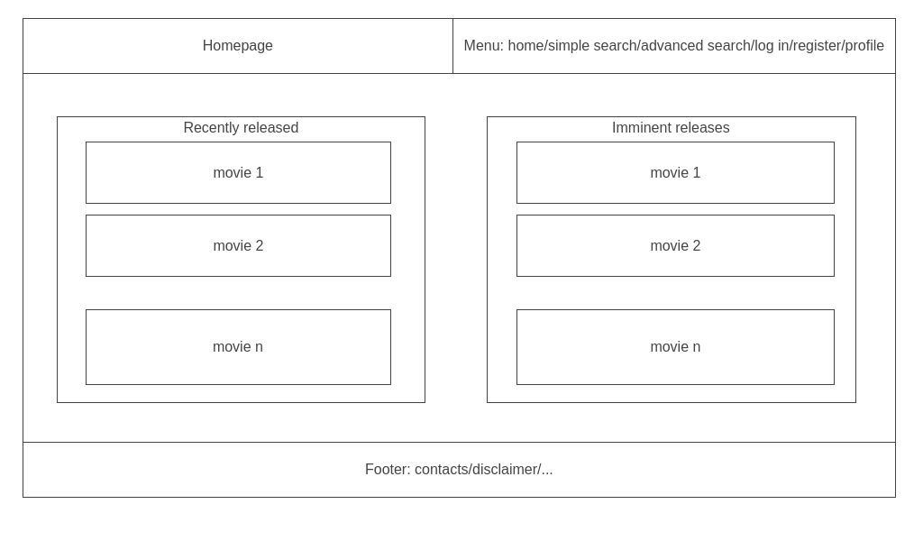
Movie/person detail
Each movie or person (cast/crew) shown in the page is linked to a dedicated detail information page. Movie and person detail page are similar but kept separated since in the following development they might diverge.

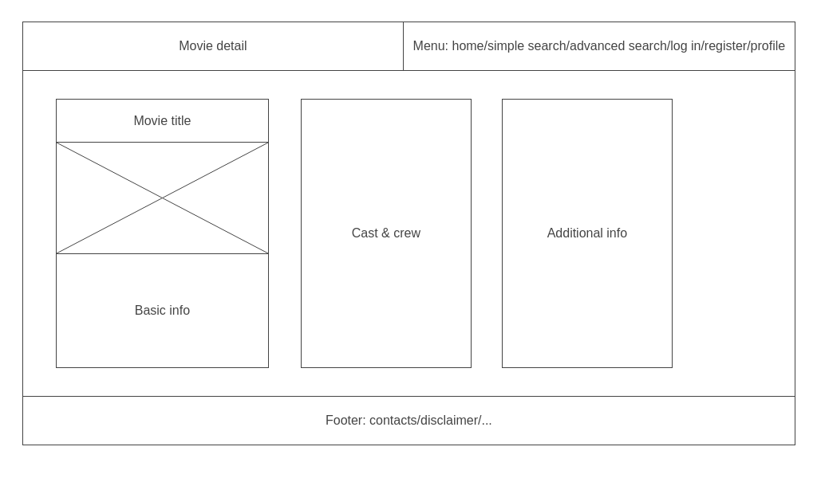
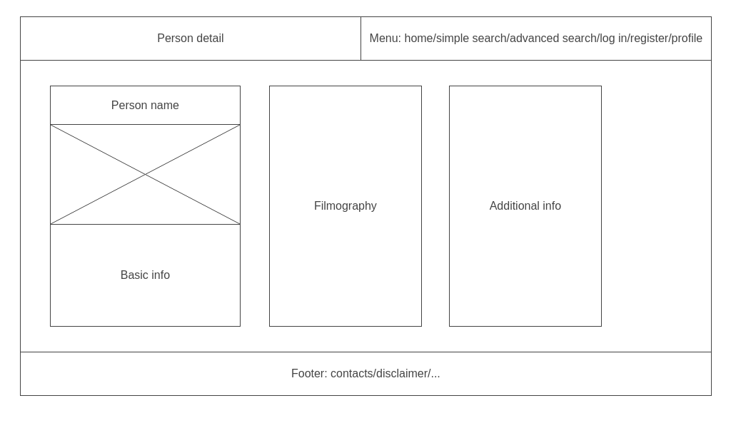
Searches
The main feature of the whole project relies on the easily performed searches, searches will be divided in two categories:
- Simple search: keyword related to one or more search fields (that can be combined)
  - title like “Casablanca”
  - cast contains “Audrey Hepburn”
  - release year is 1979
- Advanced search: searches based on complex data joining and comparison
  - in which movies did “Humphrey Bogart” and “Audrey Hepburn” play together?
  - What other films were nominated for the prizes won by Casablanca?
  - …
Advanced searches types implies a huge range of possibilities: grasping most of them with the simplest and most general possible search form is the hardest challenge of the project. In the following of the project’s development, alternative methods (or more type of pages/searches) might be added.

The search result for simple searches is a list of movies/persons respecting the applied search filter.
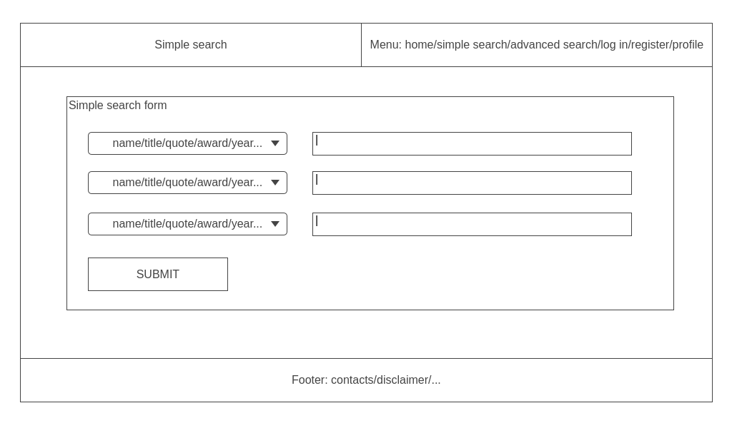

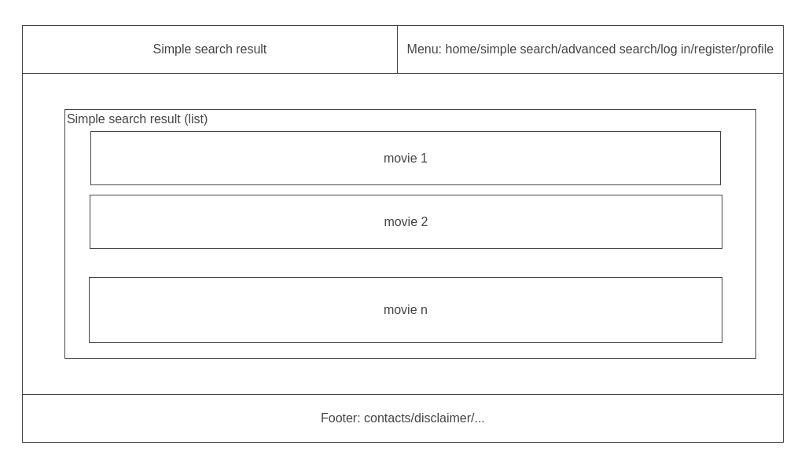

For the advanced search a more complex two-layers result structure (basically a list of lists ) will be used: in example searching for co-nominated movies (which movies were nominated to the prizes won by “Casablanca”?) will result in a list of prizes, each of which contains a list of nominated movies.
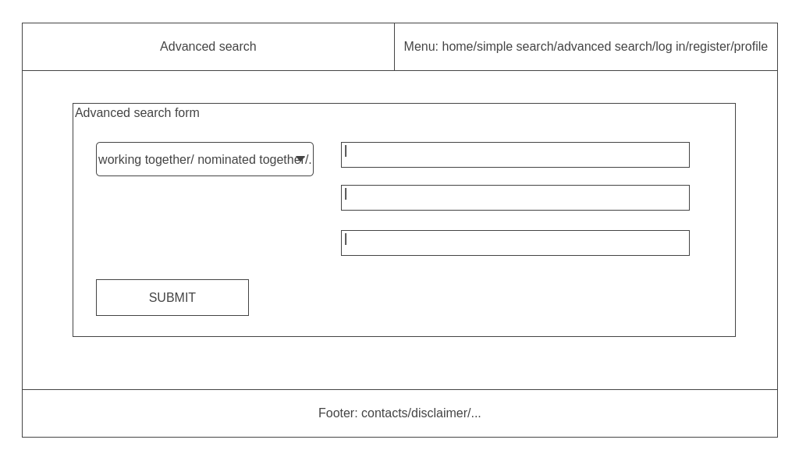
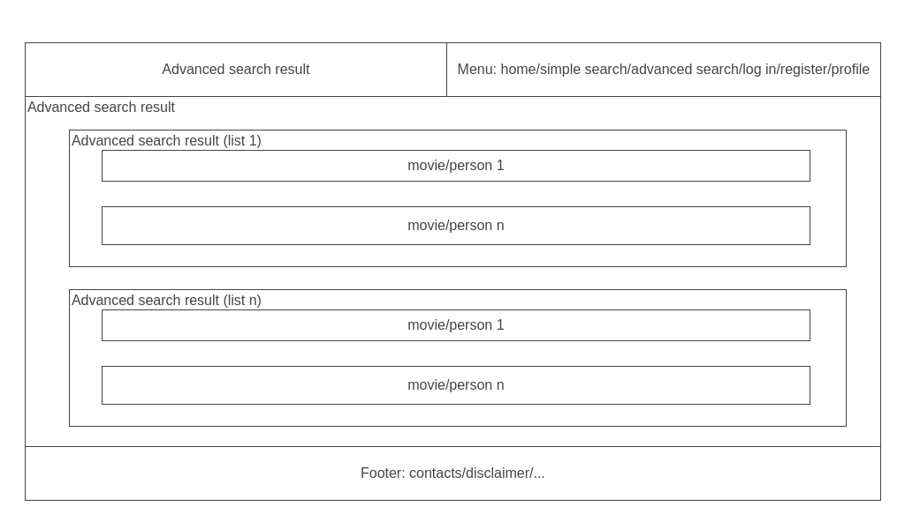
Additional pages/features
The web page will provide user profiling capabilities, this implies login/registration pages (not explicitly shown here since they will follow consolidated standards), a user profile page to insert/update user info, and a search history page, keeping track of the searches performed and allowing to repeat them.

Navigation structure
The homepage will present the user with a list of the most recently released movies and next movies to be released (the location can be provided via user profile or browser features).
Each movie (or person) in any page (home page, search result,...) is always linked to the specific page for the movie/person detailed info, as suggested by the information architecture schema below:
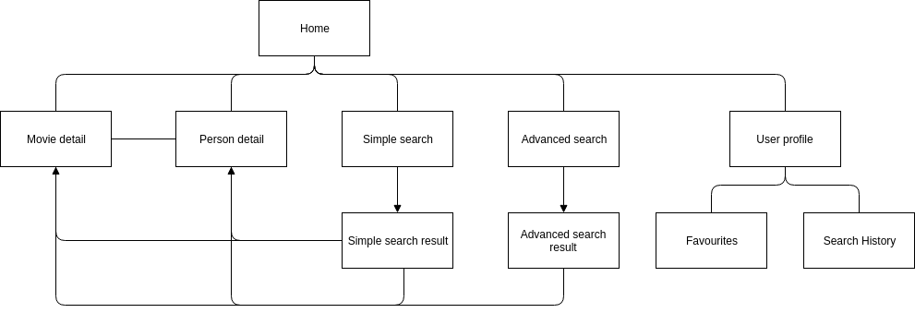

From the homepage the user can access to the detail page of any movie or person shown, perform a search (simple or advanced) or go ti the user profile. The main user profile features are: keeping track of favorites movies/person and of the searches performed. User registration and login pages are not explicitly mentioned since it will follow a standard approach.

References
The main inspiration for the web page realization is obviously IMDB (https://www.imdb.com/ ), both for good (i.e. movie details) and not so good (i.e advanced searches) pages/structures.
To access the huge and complex data base underlying IMDB, a public freemium REST API will be used: https://rapidapi.com/apidojo/api/imdb8
The front-end will be composed by responsive web pages developed using Bootstrap.

